**LOGIN PAGE**

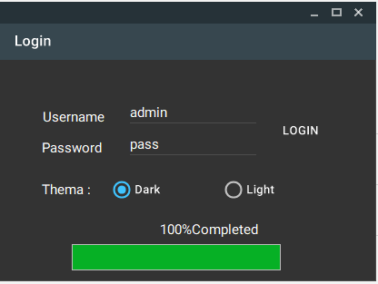

Imports MaterialSkin

Imports System.Windows.Forms.ProgressBar

Public Class Form4

Private Sub Form4_Load(sender As Object, e As EventArgs) Handles MyBase.Load

Label3.Hide()

ProgressBar1.Hide()

Dim SkinManager As MaterialSkinManager = MaterialSkinManager.Instance

SkinManager.AddFormToManage(Me)

SkinManager.Theme = MaterialSkinManager.Themes.LIGHT

End Sub

Private Sub Timer1_Tick(sender As Object, e As EventArgs) Handles Timer1.Tick

ProgressBar1.Value += 20

Label3.Text = ProgressBar1.Value & "%" & "Completed"

If ProgressBar1.Value = ProgressBar1.Maximum Then

Timer1.Stop()

MsgBox("Welcome Admin!")

Form1.Show()

Me.Hide()

End If

End Sub

Private Sub Button1_Click(sender As Object, e As EventArgs) Handles Button1.Click

If TextBox1.Text = "admin" And TextBox2.Text = "pass" Then

Timer1.Start()

ProgressBar1.Show()

Label3.Show()

Else

MsgBox("Invalid username or password", MsgBoxStyle.Critical)

End If

Private Sub RadioButton1_CheckedChanged(sender As Object, e As EventArgs) Handles RadioButton1.CheckedChanged

SkinManager.Theme = MaterialSkinManager.Themes.DARK

End Sub

Private Sub RadioButton2_CheckedChanged(sender As Object, e As EventArgs) Handles RadioButton2.CheckedChanged

SkinManager.Theme = MaterialSkinManager.Themes.LIGHT

End Sub

End Sub

End Class

**BUCH PAGE**

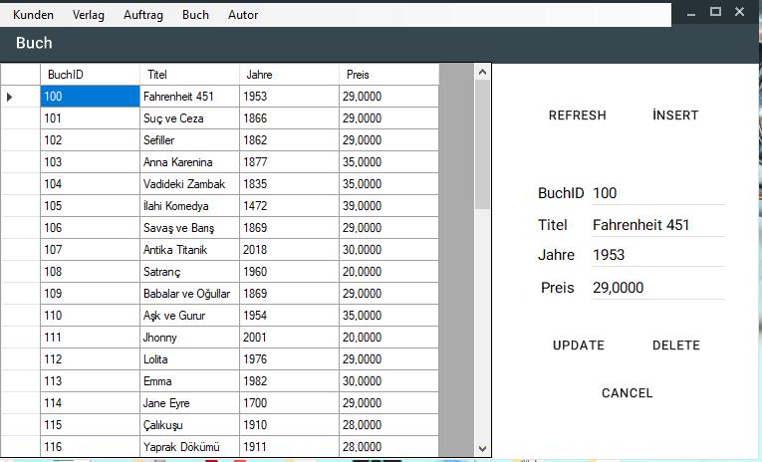

Imports System.Data.SqlClient

Imports MaterialSkin

Public Class Form1

Public Sub Form1_Load(sender As Object, e As EventArgs) Handles MyBase.Load

Dim SkinManager As MaterialSkinManager = MaterialSkinManager.Instance

SkinManager.AddFormToManage(Me)

SkinManager.Theme = MaterialSkinManager.Themes.LIGHT

SkinManager.ColorScheme = New ColorScheme(Primary.BlueGrey800, Primary.BlueGrey900, Primary.BlueGrey500, Accent.LightBlue200, TextShade.WHITE)

End Sub

Dim Buch_ID As Int32 = 0

Dim connection As SqlConnection = New SqlConnection()

Private Sub Button1_Click(sender As Object, e As EventArgs) Handles Button1.Click

DatagridView_Load()

End Sub

Private Sub Button2_Click(sender As Object, e As EventArgs) Handles Button2.Click

Form2.Visible = True

End Sub

Private Sub Button3_Click(sender As Object, e As EventArgs) Handles Button3.Click

'Update

Dim cmd As New SqlCommand

Try

cmd.CommandType = System.Data.CommandType.Text

cmd.CommandText = ("UPDATE Buch SET Titel='" & TextBox1.Text & "', Jahre='" & TextBox2.Text & "', Preis='" & TextBox3.Text & "',BuchID='" & TextBox4.Text & "' WHERE BuchID=" & Buch_ID)

cmd.Connection = connection

connection.Open()

cmd.ExecuteNonQuery()

connection.Close()

DatagridView_Load()

MsgBox("Succesfully Changed", MsgBoxStyle.Information, "update")

Catch ex As Exception

MessageBox.Show(ex.Message & vbCrLf & cmd.CommandText)

End Try

End Sub

Private Sub DataGridView1_Click(sender As Object, e As EventArgs) Handles DataGridView1.Click

Dim i As Integer

i = DataGridView1.CurrentRow.Index

Buch_ID = DataGridView1.Item(0, i).Value

Dim connection As SqlConnection = New SqlConnection()

connection.ConnectionString = "Data Source=.\SQLEXPRESS;Initial Catalog=DatenBank;Integrated Security=True"

connection.Open()

Dim adp As SqlDataAdapter = New SqlDataAdapter("select BuchID,Titel,Jahre,Preis from Buch WHERE BuchID=" & Buch_ID, connection)

Dim ds As DataSet = New DataSet()

adp.Fill(ds)

TextBox4.Text = ds.Tables(0).Rows(0).Item(0)

TextBox1.Text = ds.Tables(0).Rows(0).Item(1)

TextBox2.Text = ds.Tables(0).Rows(0).Item(2)

TextBox3.Text = ds.Tables(0).Rows(0).Item(3)

Panel1.Visible = True

connection.Close()

End Sub

Private Sub DatagridView_Load()

connection.ConnectionString = "Data Source=.\SQLEXPRESS;Initial Catalog=DatenBank;Integrated Security=True"

connection.Open()

Dim adp As SqlDataAdapter = New SqlDataAdapter("select BuchID,Titel,Jahre,Preis from Buch", connection)

Dim ds As DataSet = New DataSet()

adp.Fill(ds)

DataGridView1.DataSource = ds.Tables(0)

connection.Close()

End Sub

Private Sub Button5_Click(sender As Object, e As EventArgs) Handles Button5.Click

Panel1.Visible = False

End Sub

Private Sub Button4_Click(sender As Object, e As EventArgs) Handles Button4.Click

'Delete

Dim cmd As New SqlCommand

Try

cmd.CommandType = System.Data.CommandType.Text

cmd.CommandText = "DELETE FROM Buch WHERE BuchID =" & Buch_ID

connection.Open()

cmd.Connection = connection

cmd.ExecuteNonQuery()

connection.Close()

DatagridView_Load()

MsgBox("Succesfully Deleted " & MsgBoxStyle.Information, "delete")

Catch ex As Exception

End Try

End Sub

Private Sub KundenToolStripMenuItem_Click(sender As Object, e As EventArgs) Handles KundenToolStripMenuItem.Click

Form3.TopLevel = True

Form3.Visible = True

Me.Hide()

End Sub

Private Sub BuchlistToolStripMenuItem_Click(sender As Object, e As EventArgs)

End Sub

Private Sub AuftragToolStripMenuItem_Click(sender As Object, e As EventArgs) Handles AuftragToolStripMenuItem.Click

Auftrag.Visible = True

Me.Hide()

End Sub

Private Sub AutorToolStripMenuItem_Click(sender As Object, e As EventArgs) Handles AutorToolStripMenuItem.Click

Autor.Visible = True

Me.Hide()

End Sub

Private Sub VerlagToolStripMenuItem_Click(sender As Object, e As EventArgs) Handles VerlagToolStripMenuItem.Click

Verlag.Visible = True

Me.Hide()

End Sub

End Class

**BUCH-INSERT PAGE**

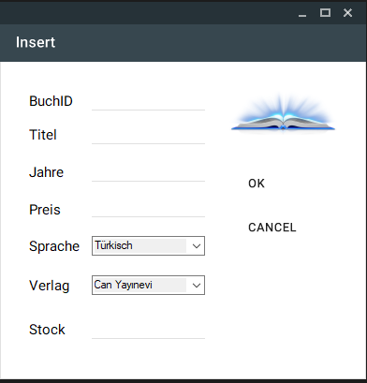

Imports System.Data.SqlClient

Imports MaterialSkin

Public Class Form2

Dim connection As SqlConnection = New SqlConnection("Data Source=.\SQLEXPRESS;Initial Catalog=DatenBank;Integrated Security=True")

Private Sub Form2_Load(sender As Object, e As EventArgs) Handles MyBase.Load

Dim SkinManager As MaterialSkinManager = MaterialSkinManager.Instance

SkinManager.AddFormToManage(Me)

SkinManager.Theme = MaterialSkinManager.Themes.LIGHT

SkinManager.ColorScheme = New ColorScheme(Primary.BlueGrey800, Primary.BlueGrey900, Primary.BlueGrey500, Accent.LightBlue200, TextShade.WHITE)

TextBox1.Clear()

TextBox2.Clear()

TextBox3.Clear()

TextBox4.Clear()

TextBox5.Clear()

Sprache_Load()

Verlag_Load()

End Sub

Private Sub Sprache_Load()

connection.Open()

Dim adp As SqlDataAdapter = New SqlDataAdapter("select * from Sprache", connection)

Dim ds As DataSet = New DataSet()

adp.Fill(ds)

ComboBox1.DataSource = ds.Tables(0)

ComboBox1.ValueMember = "SpracheID"

ComboBox1.DisplayMember = "SpracheName"

connection.Close()

End Sub

Private Sub Verlag_Load()

connection.Open()

Dim adp As SqlDataAdapter = New SqlDataAdapter("select * from Verlag", connection)

Dim ds As DataSet = New DataSet()

adp.Fill(ds)

ComboBox2.DataSource = ds.Tables(0)

ComboBox2.ValueMember = "VerlagID"

ComboBox2.DisplayMember = "VerlagName"

connection.Close()

End Sub

Private Sub Button1_Click(sender As Object, e As EventArgs) Handles Button1.Click

Dim cmd As New SqlCommand

Try

connection.Open()

cmd.CommandType = System.Data.CommandType.Text

cmd.CommandText = "Insert Into Buch values ('" & TextBox1.Text & "','" & TextBox2.Text & "','" & TextBox3.Text & "','" & TextBox4.Text & "','" & ComboBox1.SelectedValue.ToString & "','" & ComboBox2.SelectedValue.ToString & "','" &

TextBox5.Text & "')"

cmd.Connection = connection

cmd.ExecuteNonQuery()

connection.Close()

MsgBox("Succesfully Added", MsgBoxStyle.Information, "add")

Me.Hide()

Catch ex As Exception

MessageBox.Show(ex.Message)

End Try

TextBox1.Clear()

TextBox2.Clear()

TextBox3.Clear()

TextBox4.Clear()

TextBox5.Clear()

End Sub

Private Sub Button2_Click(sender As Object, e As EventArgs) Handles Button2.Click

Me.Hide()

End Sub

End Class

**KUNDEN PAGE**

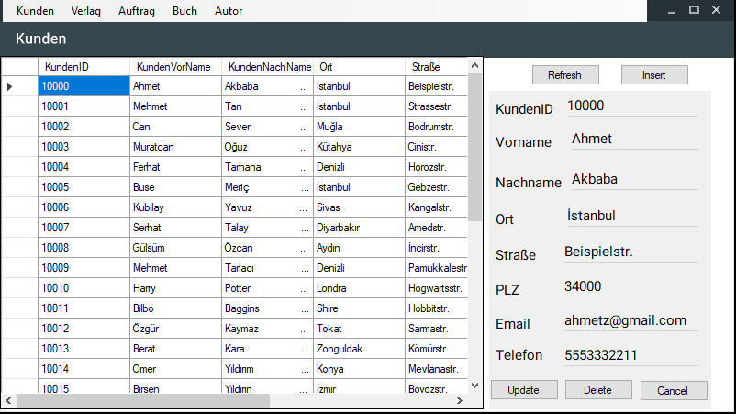

Imports System.Data.SqlClient

Public Class Form3

Dim Kunden_ID As Int32 = 0

Dim connection As SqlConnection = New SqlConnection()

Private Sub Form3_Load(sender As Object, e As EventArgs) Handles MyBase.Load

End Sub

Private Sub Button1_Click(sender As Object, e As EventArgs) Handles Button1.Click

DatagridView_Load()

End Sub

Private Sub Button2_Click(sender As Object, e As EventArgs) Handles Button2.Click

AddKunden.Visible = True

End Sub

Private Sub Button3_Click(sender As Object, e As EventArgs) Handles Button3.Click

Dim cmd As New SqlCommand

Try

cmd.CommandType = System.Data.CommandType.Text

cmd.CommandText = "UPDATE Kunden SET KundenID='" & TextBox1.Text & "', KundenVorname='" & TextBox2.Text & "', KundenNachname='" & TextBox3.Text & "', Ort='" & TextBox4.Text & "', Straße='" & TextBox5.Text & "', PLZ='" & TextBox6.Text & "', [E-Mail]='" & TextBox7.Text & "', Telefon='" & TextBox8.Text & "' WHERE KundenID=" & Kunden_ID

connection.Open()

cmd.Connection = connection

cmd.ExecuteNonQuery()

connection.Close()

DatagridView_Load()

MsgBox("Succesfully Changed", MsgBoxStyle.Information, "update")

Panel1.Visible = False

Catch ex As Exception

MessageBox.Show(ex.Message & vbCrLf & cmd.CommandText)

End Try

End Sub

Private Sub Button4_Click(sender As Object, e As EventArgs) Handles Button4.Click

Dim cmd As New SqlCommand

Try

cmd.CommandType = System.Data.CommandType.Text

cmd.CommandText = ("DELETE FROM Kunden WHERE KundenID=" & Kunden_ID)

connection.Open()

cmd.Connection = connection

cmd.ExecuteNonQuery()

connection.Close()

DatagridView_Load()

MsgBox("Succesfully Deleted", MsgBoxStyle.Information, "delete")

Catch ex As Exception

MessageBox.Show(ex.Message & vbCrLf & cmd.CommandText)

End Try

End Sub

Private Sub DataGridView1_Click(sender As Object, e As EventArgs) Handles DataGridView1.Click

Dim i As Integer

i = DataGridView1.CurrentRow.Index

Kunden_ID = DataGridView1.Item(0, i).Value

Dim connection As SqlConnection = New SqlConnection()

connection.ConnectionString = "Data Source=.\SQLEXPRESS;Initial Catalog=DatenBank;Integrated Security=True"

connection.Open()

Dim adp As SqlDataAdapter = New SqlDataAdapter("select * from Kunden WHERE KundenID=" & Kunden_ID, connection)

Dim ds As DataSet = New DataSet()

adp.Fill(ds)

TextBox1.Text = ds.Tables(0).Rows(0).Item(0)

TextBox2.Text = ds.Tables(0).Rows(0).Item(1)

TextBox3.Text = ds.Tables(0).Rows(0).Item(2)

TextBox4.Text = ds.Tables(0).Rows(0).Item(3)

TextBox5.Text = ds.Tables(0).Rows(0).Item(4)

TextBox6.Text = ds.Tables(0).Rows(0).Item(5)

TextBox7.Text = ds.Tables(0).Rows(0).Item(6)

TextBox8.Text = ds.Tables(0).Rows(0).Item(7)

Panel1.Visible = True

connection.Close()

End Sub

Private Sub DatagridView_Load()

connection.ConnectionString = "Data Source=.\SQLEXPRESS;Initial Catalog=DatenBank;Integrated Security=True"

connection.Open()

Dim adp As SqlDataAdapter = New SqlDataAdapter("select * from Kunden", connection)

Dim ds As DataSet = New DataSet()

adp.Fill(ds)

DataGridView1.DataSource = ds.Tables(0)

connection.Close()

End Sub

Private Sub BuchlistToolStripMenuItem_Click(sender As Object, e As EventArgs) Handles BuchlistToolStripMenuItem.Click

Me.TopLevel = False

Form1.Show()

End Sub

Private Sub AuftragToolStripMenuItem_Click(sender As Object, e As EventArgs) Handles AuftragToolStripMenuItem.Click

Auftrag.Visible = True

Me.Hide()

End Sub

Private Sub AutorToolStripMenuItem_Click(sender As Object, e As EventArgs) Handles AutorToolStripMenuItem.Click

Autor.Visible = True

Me.Hide()

End Sub

Private Sub VerlagToolStripMenuItem_Click(sender As Object, e As EventArgs) Handles VerlagToolStripMenuItem.Click

Verlag.Visible = True

Me.Hide()

End Sub

Private Sub Button5_Click(sender As Object, e As EventArgs) Handles Button5.Click

Me.Hide()

End Sub

End Class

**KUNDEN INSERT PAGE**

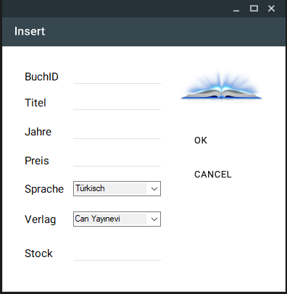

Imports System.Data.SqlClient

Imports MaterialSkin

Public Class AddKunden

Dim connection As SqlConnection = New SqlConnection("Data Source=.\SQLEXPRESS;Initial Catalog=DatenBank;Integrated Security=True")

Private Sub AddKunden_Load(sender As Object, e As EventArgs) Handles MyBase.Load

Dim SkinManager As MaterialSkinManager = MaterialSkinManager.Instance

SkinManager.AddFormToManage(Me)

SkinManager.Theme = MaterialSkinManager.Themes.LIGHT

SkinManager.ColorScheme = New ColorScheme(Primary.BlueGrey800, Primary.BlueGrey900, Primary.BlueGrey500, Accent.LightBlue200, TextShade.WHITE)

TextBox1.Clear()

TextBox2.Clear()

TextBox3.Clear()

TextBox4.Clear()

TextBox5.Clear()

TextBox6.Clear()

TextBox7.Clear()

TextBox8.Clear()

End Sub

Private Sub Button1_Click(sender As Object, e As EventArgs) Handles Button1.Click

Dim cmd As New SqlCommand

Try

connection.Open()

cmd.CommandType = System.Data.CommandType.Text

cmd.CommandText = "Insert Into Kunden values ('" & TextBox1.Text & "','" & TextBox2.Text & "','" & TextBox3.Text & "','" & TextBox4.Text & "','" & TextBox5.Text & "','" & TextBox6.Text & "','" & TextBox7.Text & "', '" & TextBox8.Text & "')"

cmd.Connection = connection

cmd.ExecuteNonQuery()

connection.Close()

MsgBox("Succesfully Added", MsgBoxStyle.Information, "add")

Me.Hide()

Catch ex As Exception

MessageBox.Show(ex.Message)

End Try

TextBox1.Clear()

TextBox2.Clear()

TextBox3.Clear()

TextBox4.Clear()

TextBox5.Clear()

TextBox6.Clear()

TextBox7.Clear()

TextBox8.Clear()

End Sub

Private Sub Button2_Click(sender As Object, e As EventArgs) Handles Button2.Click

Form3.Show()

Me.Hide()

End Sub

End Class

**VERLAG PAGE**

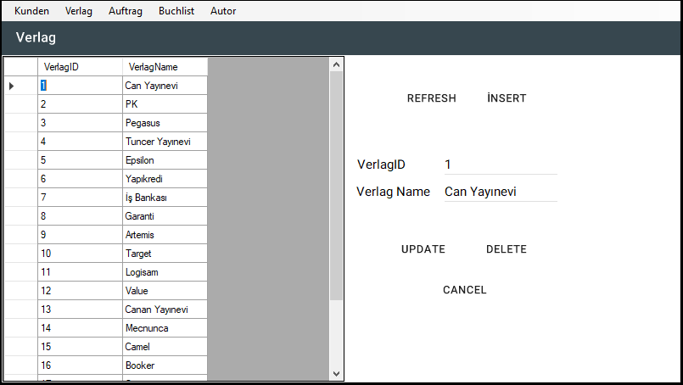

Imports System.Data.SqlClient

Imports MaterialSkin

Public Class Verlag

Private Sub Verlag_Load(sender As Object, e As EventArgs) Handles MyBase.Load

Dim SkinManager As MaterialSkinManager = MaterialSkinManager.Instance

SkinManager.AddFormToManage(Me)

SkinManager.Theme = MaterialSkinManager.Themes.LIGHT

SkinManager.ColorScheme = New ColorScheme(Primary.BlueGrey800, Primary.BlueGrey900, Primary.BlueGrey500, Accent.LightBlue200, TextShade.WHITE)

End Sub

Dim Verlag_ID As Int32 = 0

Dim connection As SqlConnection = New SqlConnection()

Private Sub Button1_Click(sender As Object, e As EventArgs) Handles Button1.Click

DatagridView_Load()

End Sub

Private Sub Button2_Click(sender As Object, e As EventArgs) Handles Button2.Click

AddVerlag.Visible = True

End Sub

Private Sub Button3_Click(sender As Object, e As EventArgs) Handles Button3.Click

'Update

Dim cmd As New SqlCommand

Try

cmd.CommandType = System.Data.CommandType.Text

cmd.CommandText = ("UPDATE Verlag SET VerlagID='" & TextBox4.Text & "', VerlagName='" & TextBox1.Text & "' WHERE VerlagID=" & Verlag_ID)

cmd.Connection = connection

connection.Open()

cmd.ExecuteNonQuery()

connection.Close()

DatagridView_Load()

MsgBox("Succesfully Changed", MsgBoxStyle.Information, "update")

Catch ex As Exception

MessageBox.Show(ex.Message & vbCrLf & cmd.CommandText)

End Try

End Sub

Private Sub DataGridView1_Click(sender As Object, e As EventArgs) Handles DataGridView1.Click

Dim i As Integer

i = DataGridView1.CurrentRow.Index

Verlag_ID = DataGridView1.Item(0, i).Value

Dim connection As SqlConnection = New SqlConnection()

connection.ConnectionString = "Data Source=.\SQLEXPRESS;Initial Catalog=DatenBank;Integrated Security=True"

connection.Open()

Dim adp As SqlDataAdapter = New SqlDataAdapter("select VerlagID,VerlagName from Verlag WHERE VerlagID=" & Verlag_ID, connection)

Dim ds As DataSet = New DataSet()

adp.Fill(ds)

TextBox4.Text = ds.Tables(0).Rows(0).Item(0)

TextBox1.Text = ds.Tables(0).Rows(0).Item(1)

Panel1.Visible = True

connection.Close()

End Sub

Private Sub DatagridView_Load()

connection.ConnectionString = "Data Source=.\SQLEXPRESS;Initial Catalog=DatenBank;Integrated Security=True"

connection.Open()

Dim adp As SqlDataAdapter = New SqlDataAdapter("select VerlagID,VerlagName from Verlag", connection)

Dim ds As DataSet = New DataSet()

adp.Fill(ds)

DataGridView1.DataSource = ds.Tables(0)

connection.Close()

End Sub

Private Sub Button5_Click(sender As Object, e As EventArgs) Handles Button5.Click

Panel1.Visible = False

End Sub

Private Sub Button4_Click(sender As Object, e As EventArgs) Handles Button4.Click

Dim cmd As New SqlCommand

Try

cmd.CommandType = System.Data.CommandType.Text

cmd.CommandText = "DELETE FROM Verlag WHERE VerlagID =" & Verlag_ID

connection.Open()

cmd.Connection = connection

cmd.ExecuteNonQuery()

connection.Close()

DatagridView_Load()

MsgBox("Succesfully Deleted " & MsgBoxStyle.Information, "delete")

Panel1.Visible = False

Catch ex As Exception

End Try

End Sub

Private Sub KundenToolStripMenuItem_Click(sender As Object, e As EventArgs) Handles KundenToolStripMenuItem.Click

Form3.TopLevel = True

Form3.Visible = True

Me.Hide()

End Sub

Private Sub BuchlistToolStripMenuItem_Click(sender As Object, e As EventArgs) Handles BuchlistToolStripMenuItem.Click

Form1.Visible = True

Me.Hide()

End Sub

Private Sub AuftragToolStripMenuItem_Click(sender As Object, e As EventArgs) Handles AuftragToolStripMenuItem.Click

Auftrag.Visible = True

Me.Hide()

End Sub

Private Sub AutorToolStripMenuItem_Click(sender As Object, e As EventArgs) Handles AutorToolStripMenuItem.Click

Autor.Visible = True

Me.Hide()

End Sub

End Class

**VERLAG INSERT PAGE**

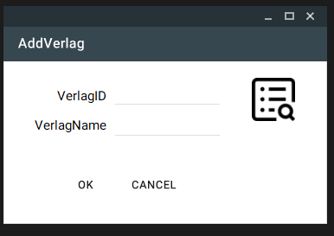

Imports MaterialSkin

Imports System.Data.SqlClient

Public Class AddVerlag

Dim connection As SqlConnection = New SqlConnection("Data Source=.\SQLEXPRESS;Initial Catalog=DatenBank;Integrated Security=True")

Private Sub AddVerlag_Load(sender As Object, e As EventArgs) Handles MyBase.Load

Dim SkinManager As MaterialSkinManager = MaterialSkinManager.Instance

SkinManager.AddFormToManage(Me)

SkinManager.Theme = MaterialSkinManager.Themes.LIGHT

SkinManager.ColorScheme = New ColorScheme(Primary.BlueGrey800, Primary.BlueGrey900, Primary.BlueGrey500, Accent.LightBlue200, TextShade.WHITE)

TextBox1.Clear()

TextBox2.Clear()

End Sub

Private Sub Button1_Click(sender As Object, e As EventArgs) Handles Button1.Click

Dim cmd As New SqlCommand

Try

connection.Open()

cmd.CommandType = System.Data.CommandType.Text

cmd.CommandText = "Insert Into Verlag values ('" & TextBox1.Text & "','" & TextBox2.Text & "')"

cmd.Connection = connection

cmd.ExecuteNonQuery()

connection.Close()

MsgBox("Succesfully Added", MsgBoxStyle.Information, "add")

Catch ex As Exception

MessageBox.Show(ex.Message)

End Try

TextBox1.Clear()

TextBox2.Clear()

End Sub

Private Sub Button2_Click(sender As Object, e As EventArgs) Handles Button2.Click

Me.Hide()

End Sub

End Class

**AUTOR PAGE**

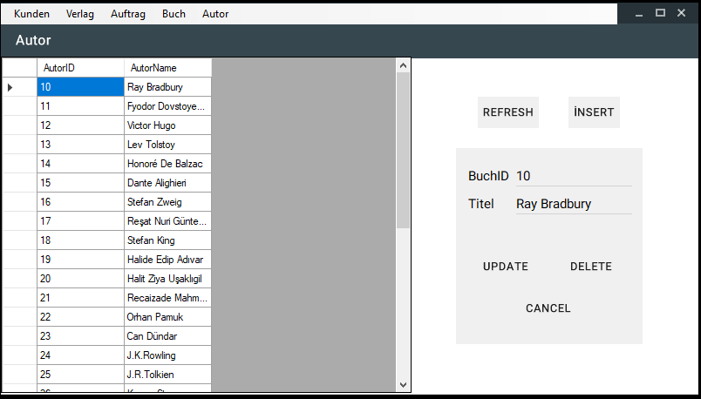

Imports System.Data.SqlClient

Imports MaterialSkin

Public Class Autor

Public Sub Autor_Load(sender As Object, e As EventArgs)

Dim SkinManager As MaterialSkinManager = MaterialSkinManager.Instance

SkinManager.AddFormToManage(Me)

SkinManager.Theme = MaterialSkinManager.Themes.LIGHT

SkinManager.ColorScheme = New ColorScheme(Primary.BlueGrey800, Primary.BlueGrey900, Primary.BlueGrey500, Accent.LightBlue200, TextShade.WHITE)

End Sub

Dim Autor_ID As Int32 = 0

Dim connection As SqlConnection = New SqlConnection()

Private Sub Button1_Click(sender As Object, e As EventArgs) Handles Button1.Click

DatagridView_Load()

End Sub

Private Sub Button2_Click(sender As Object, e As EventArgs) Handles Button2.Click

AddAutor.Visible = True

End Sub

Private Sub Button3_Click(sender As Object, e As EventArgs) Handles Button3.Click

Dim cmd As New SqlCommand

Try

cmd.CommandType = System.Data.CommandType.Text

cmd.CommandText = ("UPDATE Autor SET AutorID='" & TextBox4.Text & "', AutorName='" & TextBox1.Text & "' WHERE AutorID=" & Autor_ID)

cmd.Connection = connection

connection.Open()

cmd.ExecuteNonQuery()

connection.Close()

DatagridView_Load()

MsgBox("Succesfully Changed", MsgBoxStyle.Information, "update")

Panel1.Visible = False

Catch ex As Exception

MessageBox.Show(ex.Message & vbCrLf & cmd.CommandText)

End Try

End Sub

Private Sub DataGridView1_Click(sender As Object, e As EventArgs) Handles DataGridView1.Click

Dim i As Integer

i = DataGridView1.CurrentRow.Index

Autor_ID = DataGridView1.Item(0, i).Value

Dim connection As SqlConnection = New SqlConnection()

connection.ConnectionString = "Data Source=.\SQLEXPRESS;Initial Catalog=DatenBank;Integrated Security=True"

connection.Open()

Dim adp As SqlDataAdapter = New SqlDataAdapter("select AutorID,AutorName from Autor WHERE AutorID=" & Autor_ID, connection)

Dim ds As DataSet = New DataSet()

adp.Fill(ds)

TextBox4.Text = ds.Tables(0).Rows(0).Item(0)

TextBox1.Text = ds.Tables(0).Rows(0).Item(1)

Panel1.Visible = True

connection.Close()

End Sub

Private Sub DatagridView_Load()

connection.ConnectionString = "Data Source=.\SQLEXPRESS;Initial Catalog=DatenBank;Integrated Security=True"

connection.Open()

Dim adp As SqlDataAdapter = New SqlDataAdapter("select AutorID, AutorName from Autor", connection)

Dim ds As DataSet = New DataSet()

adp.Fill(ds)

DataGridView1.DataSource = ds.Tables(0)

connection.Close()

End Sub

Private Sub Button5_Click(sender As Object, e As EventArgs) Handles Button5.Click

Panel1.Visible = False

End Sub

Private Sub Button4_Click(sender As Object, e As EventArgs) Handles Button4.Click

'Delete

Dim cmd As New SqlCommand

Try

cmd.CommandType = System.Data.CommandType.Text

cmd.CommandText = "DELETE FROM Autor WHERE AutorID =" & Autor_ID

connection.Open()

cmd.Connection = connection

cmd.ExecuteNonQuery()

connection.Close()

DatagridView_Load()

MsgBox("Succesfully Deleted " & MsgBoxStyle.Information, "delete")

TextBox1.Clear()

TextBox4.Clear()

Catch ex As Exception

End Try

End Sub

Private Sub BuchlistToolStripMenuItem_Click(sender As Object, e As EventArgs) Handles BuchlistToolStripMenuItem.Click

Me.TopLevel = False

Form1.Show()

End Sub

Private Sub AuftragToolStripMenuItem_Click(sender As Object, e As EventArgs) Handles AuftragToolStripMenuItem.Click

Auftrag.Visible = True

Me.Hide()

End Sub

Private Sub KundenToolStripMenuItem_Click(sender As Object, e As EventArgs) Handles KundenToolStripMenuItem.Click

Form3.Visible = True

Me.Hide()

End Sub

Private Sub VerlagToolStripMenuItem_Click(sender As Object, e As EventArgs) Handles VerlagToolStripMenuItem.Click

Verlag.Visible = True

Me.Hide()

End Sub

Private Sub Autor_Load_1(sender As Object, e As EventArgs) Handles MyBase.Load

End Sub

End Class

**AUTOR INSERT PAGE**

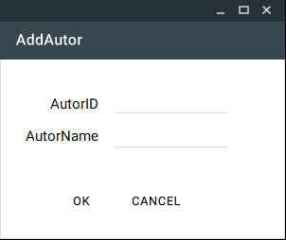

Imports MaterialSkin

Imports System.Data.SqlClient

Public Class AddAutor

Dim connection As SqlConnection = New SqlConnection("Data Source=.\SQLEXPRESS;Initial Catalog=DatenBank;Integrated Security=True")

Private Sub AddAutor_Load(sender As Object, e As EventArgs) Handles MyBase.Load

Dim SkinManager As MaterialSkinManager = MaterialSkinManager.Instance

SkinManager.AddFormToManage(Me)

SkinManager.Theme = MaterialSkinManager.Themes.LIGHT

SkinManager.ColorScheme = New ColorScheme(Primary.BlueGrey800, Primary.BlueGrey900, Primary.BlueGrey500, Accent.LightBlue200, TextShade.WHITE)

TextBox1.Clear()

TextBox2.Clear()

End Sub

Private Sub Button1_Click(sender As Object, e As EventArgs) Handles Button1.Click

Dim cmd As New SqlCommand

Try

connection.Open()

cmd.CommandType = System.Data.CommandType.Text

cmd.CommandText = "Insert Into Autor values ('" & TextBox1.Text & "','" & TextBox2.Text & "')"

cmd.Connection = connection

cmd.ExecuteNonQuery()

connection.Close()

MsgBox("Succesfully Added", MsgBoxStyle.Information, "add")

Catch ex As Exception

MessageBox.Show(ex.Message)

End Try

TextBox1.Clear()

TextBox2.Clear()

End Sub

Private Sub Button2_Click(sender As Object, e As EventArgs) Handles Button2.Click

Me.Hide()

End Sub

End Class